**COMPUTER PROJECT**

**LATTICE STRUCTURE VISUALISER**

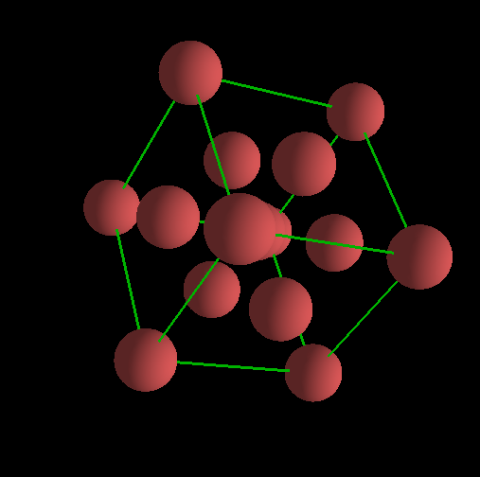

Name: ASHMAN SINGH

Class: XII C

School: DELHI PUBLIC SCHOOL BANGLORE SOUTH

ROLL NO:

2023-2024

**INDEX**

|  |  |  |
| --- | --- | --- |
| **SNO** | **CONTENT** | **PAGENO** |
| **1** | **ACKNOWLEDGEMENT** | **3** |
| **2** | **CERTIFICATE** | **4** |
| **3** | **OBJECTIVE** | **5** |
| **4** | **PROBLEM DEFINATION** | **6** |
| **5** | **ANALYSIS** | **6** |
| **6** | **BLOCK DIAGRAM** | **7** |
| **7** | **CODE** | **8** |
| **8** | **OUTPUT** | **17** |
| **9** | **BIBLIOGRAPHY** | **19** |

**ACKNOWLEDGEMENT**

I would like to thank my school, and the Principal, Mrs Anitha Bijesh for providing me with an opportunity to take part in this project.

I would also like to express my heartfelt thanks to my Computer Science teacher Mrs. Ranjtiha ma’am for guiding me and helping me complete my project successfully.

**DELHI PUBLIC SCHOOL**

**BANGLORE SOUTH**

NAME: Ashman Singh

CLASS: XII C

ROLL NUMBER:

This is certified to be bonafide work of the student in the **COMPUTER LABORATORY** during the academic year 2023-24

Teacher in charge: ____________

Examiner’s Signature:__________

Principal’s Signature:___________

School Seal:

Date:__________

**OBJECTIVE**

Students in class XII come across a topic in chemistry called “Solid State Chemistry”. While attending the lecture I realised a lot of students struggled with visualising the lattice structures like FCC(Face Centric) and BCC(Body Centric).

Our mission is to allow students to view the actual 3D models and interact with them without purchasing expensive models from the market.

**PROBLEM DEFINATION**

**­**We want to render 3D models of both the lattice structures, provide a method to view the models and to provide an GUI to interface everything. The models will we rendered using an wrapper for OpenGL in python. To initialise the window and to accept inputs, PyGame will be used and for the GUI PyOpen_GUI will be used.

**MODULES USED:**

* **PyOpenGL**
* **PyOpenGL_accelerate**
* **Pygame**
* **Pygame_GUI**

**ANALYSIS**

**INPUT DESCRIPTION**

The input consists of the user selecting which structure they wish to view and to change the radius by their own accord. This radius can be save on a text file. The user can also use arrow keys to move around.

**OUTPUT DESCRPTION**

The output will render the respective 3D model on the screen with the given radius.

**FLOW CHART**

Start **ANALYSIS**

Has 8 spheres along its vertices. This has viewing functionality as well as radius changing and saving.

Has 8 spheres along its vertices and 6 spheres on each of the cubes face. This has viewing functionality as well as radius changing and saving.

UI.py

FCC.py

BCC.py

Csvoutput.py

Radiussaver.py

Data.csv

Data.txt

Radiussaver.py will read and save the radius depending on function call

Csvoutput.py will read the coordinate values and convert it into appropriate format for OpenGL

**UI.py**

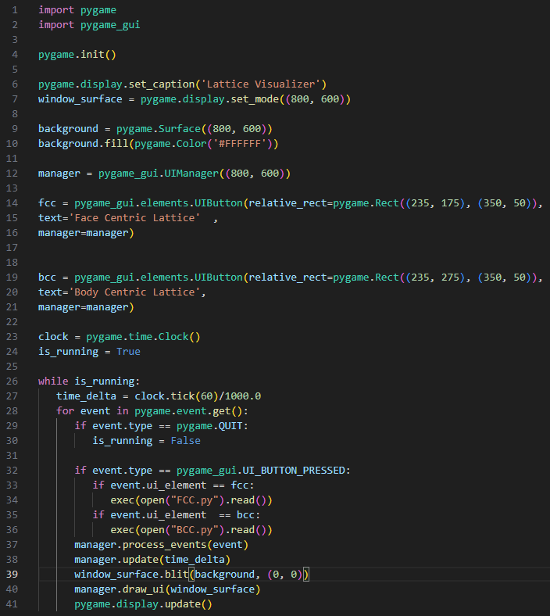

**BCC.py**

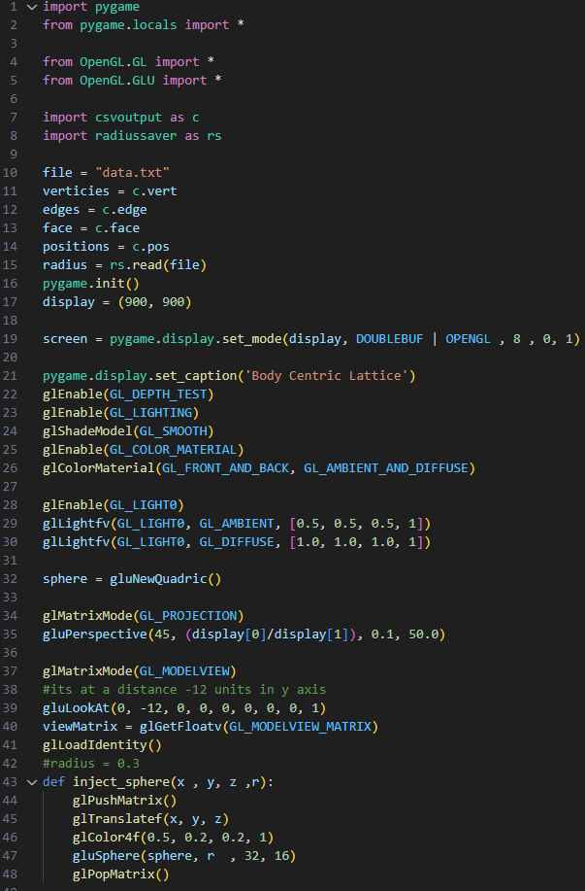

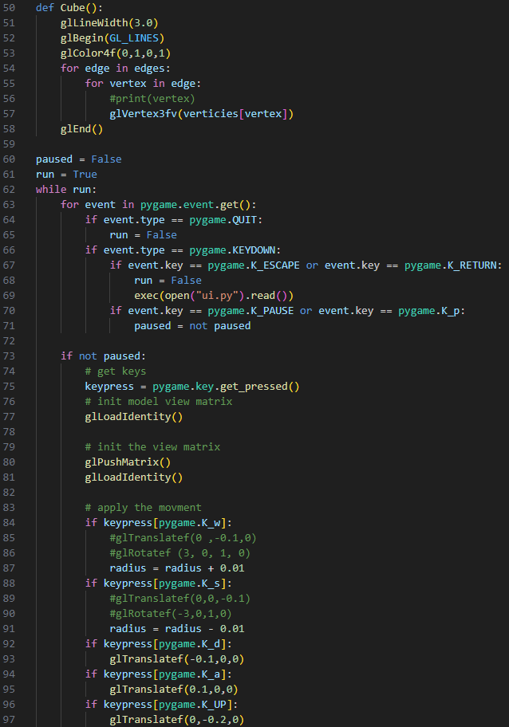

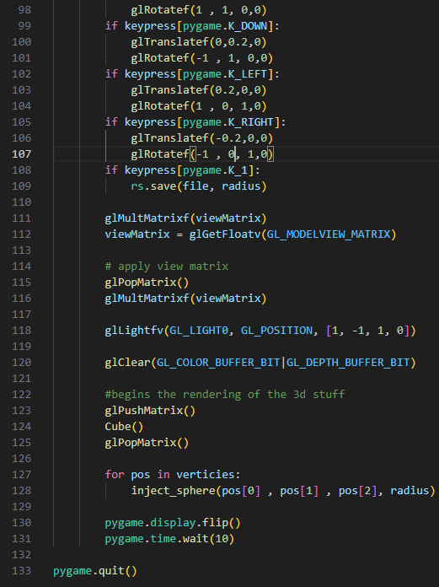

**FCC.py**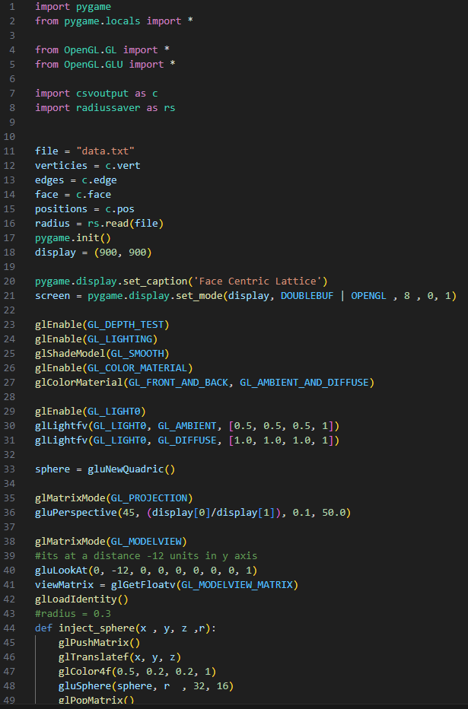

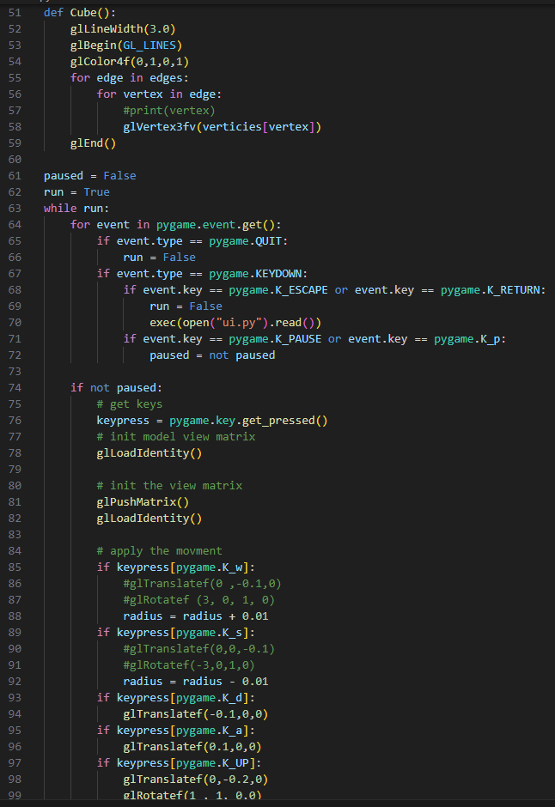

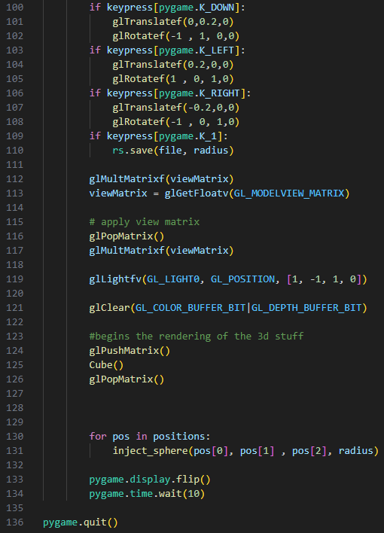

**Csvoutput.py**

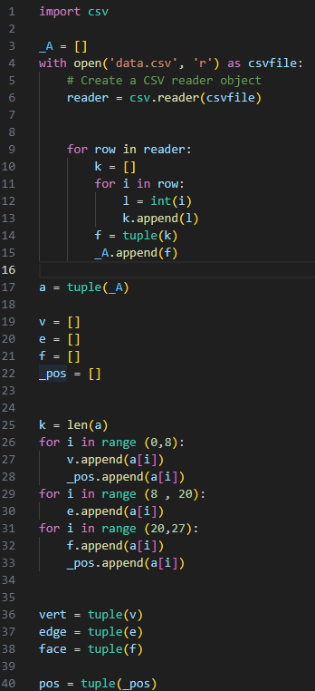

**radiusaver.py**

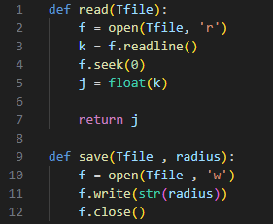

**OUTPUTS**

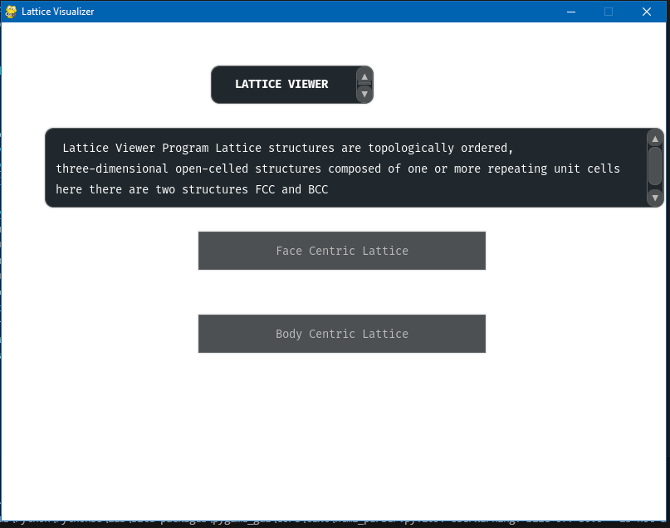

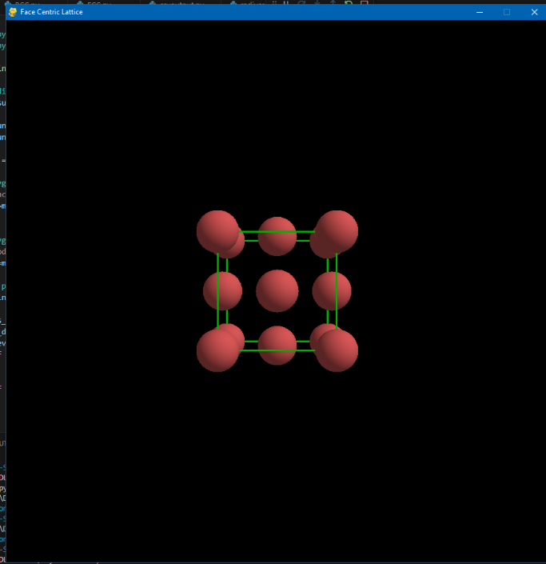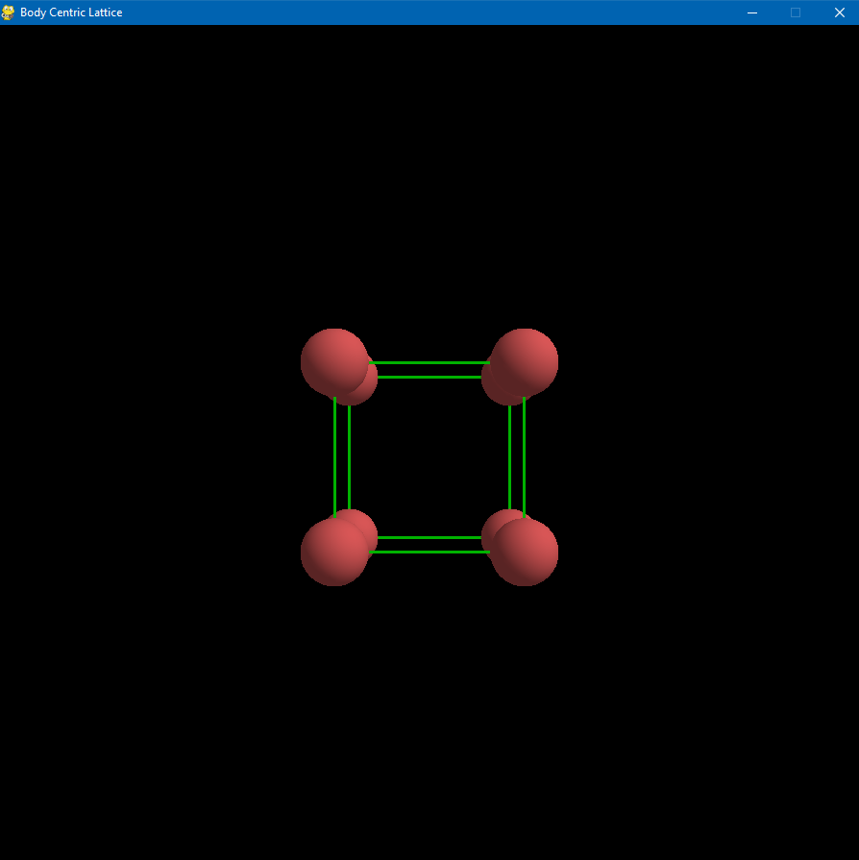

Body Centric ↑ Face Centric ↑

**Radius Saving Feature**

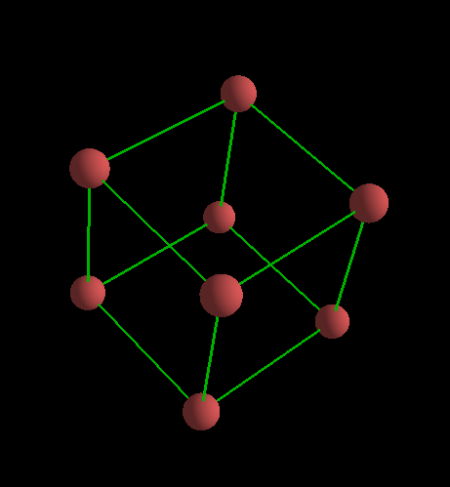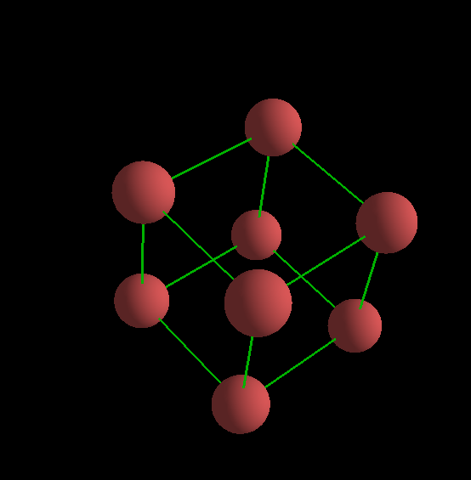

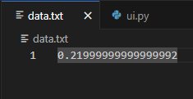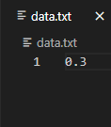

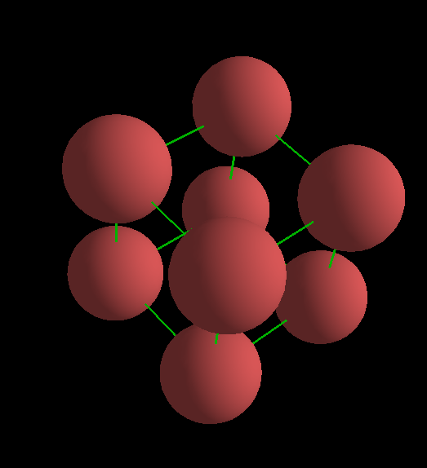

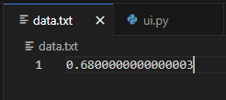

**Coordinate data saved on csv file**

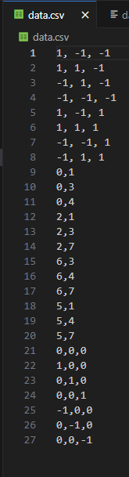

**BIBLIOGRAPHY**

<https://community.khronos.org/>

<https://registry.khronos.org/>

<https://www.pygame.org/docs/>

<https://pyopengl.sourceforge.net/documentation/index.html>

<https://pygame-gui.readthedocs.io/en/v_069/>

<https://github.com/MyreMylar/pygame_gui_examples>

**GITHUB**

<https://github.com/thinkter/Lattice-Structure-Visualizer>